**10 SCIENCE INVESTIGATION**

GREENHOUSE EFFECT

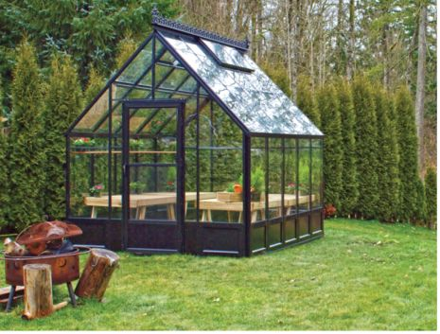

Name:_________________ Teacher:____________

Form:_________________ Due date:___________

**IMPORTANT INFORMATION**

**Plagiarism**

•The experiment is to be done in your science group but your write-up and results are to be done individually.

•Plagiarising = instant zero on assignment and you will have to re-do it.

**Presentation**

•Neat writing (if you struggle with this, type your information).

•Correct spelling, grammar and full sentences.

**Assessment policy**

Have sick note/legitimate reason from parent = new negotiated due date.

Assignment not submitted on due date and no sick note from parents = -20% mark

Assignment not submitted on new negotiated due date = -40% mark

+ Letter home to parents

+ Must attend academic completion to complete assignment

**OR**

Submit assignment to student services before academic completion date and academic completion not necessary.

Academic completion not attended = zero on assignment + Saturday detention

**If you know that you cannot submit your assignment on the due date, let your teacher know BEFORE the due date (email them if you are not in school) or just email them your assignment the night before.**

**Aim:** To investigate the greenhouse effect by making a model of a greenhouse.

**Materials** (materials in a list, detailed, how many of each item). **(2 marks)**

_________________________________ __________________________________

_________________________________ __________________________________

_________________________________ __________________________________

_________________________________ __________________________________

**Hypothesis** (one sentence prediction of what will happen). **(2 marks)**

_________________________________________________________________________________

_________________________________________________________________________________

_________________________________________________________________________________

_________________________________________________________________________________

_________________________________________________________________________________

**Independent variable: (1 mark)**

_________________________________________________________________________________

**Dependent variable: (1 mark)**

_________________________________________________________________________________

**Two controlled variables: (2 marks)**

_________________________________________________________________________________

_________________________________________________________________________________

**Method**

1. Create a hole in one of the pieces of cardboard, just large enough for the thermometer to pass through. Use the modelling clay to hold the thermometer in place. It needs to be a good seal, to stop air escaping.

2. Construct the model greenhouse as shown below.

3. Place the ‘greenhouse’ outside in a sunny position.

4. Place the second thermometer on the block of wood next to the greenhouse. Make sure that the bulb of the thermometer is suspended in the air.

5. Record the temperatures of the two thermometers at the beginning of the experiment.

6. Record the temperatures every 2 minutes for 14 minutes.

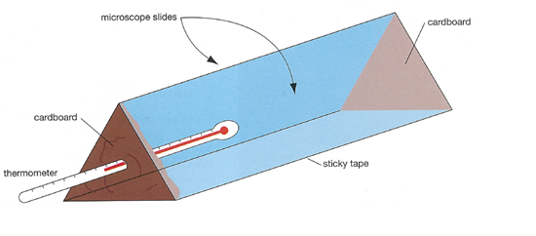

**Results: table (3 marks)**

(Show results taken from experiment, in pencil, with ruler).

**Graph:** show your group results, Draw on graph paper and attach. **(6 marks)**

**BOTH SETS OF DATA MUST BE ON THE ONE GRAPH!**

- Use graph paper.

- Use a sharp pencil and ruler.

- Have a title at the top (independent variable versus dependent variable).

- Work out whether you need to draw a bar graph (different groups of data) or a line graph (showing data changing over time).

- Put the independent variable and dependent variable on the correct axis.

- Label each axis.

- Record the units of measurement in brackets next to each label.

- Use an appropriate scale that has the same pattern the whole way along.

**Discussion: (6 marks)**

(Describe two mistakes/errors that occurred, explain how they affected the results and how they could be avoided next time).

_________________________________________________________________________________

_________________________________________________________________________________

_________________________________________________________________________________

_________________________________________________________________________________

_________________________________________________________________________________

_________________________________________________________________________________

_________________________________________________________________________________

_________________________________________________________________________________

_________________________________________________________________________________

_________________________________________________________________________________

_________________________________________________________________________________

_________________________________________________________________________________

_________________________________________________________________________________

_________________________________________________________________________________

_________________________________________________________________________________

_________________________________________________________________________________

_________________________________________________________________________________

**1.** Explain why the second thermometer recording air temperature was used.

**(2 marks)**

_________________________________________________________________________________

_________________________________________________________________________________

_________________________________________________________________________________

_________________________________________________________________________________

_________________________________________________________________________________

**2.** Compare the temperature patterns inside and outside the greenhouse. **(2 marks)**

_________________________________________________________________________________

_________________________________________________________________________________

_________________________________________________________________________________

**3.** Discuss any other factors that could have affected the temperature. **(2 marks)**

_________________________________________________________________________________

_________________________________________________________________________________

_________________________________________________________________________________

_________________________________________________________________________________

**4.** Explain what has happened in this model of the greenhouse effect. **(2 marks)**

_________________________________________________________________________________

_________________________________________________________________________________

_________________________________________________________________________________

_________________________________________________________________________________

**5.** Compare the model in this experiment to the global greenhouse effect.**(2 marks)**

_________________________________________________________________________________

_________________________________________________________________________________

_________________________________________________________________________________

_________________________________________________________________________________

**Conclusion: (2 marks)**

_________________________________________________________________________________

_________________________________________________________________________________

_________________________________________________________________________________

_________________________________________________________________________________

_________________________________________________________________________________

_________________________________________________________________________________

**MARKING KEY**

|  |  |  |  |
| --- | --- | --- | --- |
| **Content** | **Description** |  | **Your**  **mark** |
| Materials | Is written in a list  Includes all materials and amounts | 1  1 |  |
| Hypothesis | Correctly worded (e.g. if, then statement).  Includes both dependent and independent variable. | 1  1 |  |
| Independent  Variable | Listed the independent variable. | 1 |  |
| Dependent  Variable | Listed the dependent variable. | 1 |  |
| Controlled  Variables | Listed two controlled variables. | 2 |  |
| Results  table | Drawn neatly in pencil and using a ruler.  Includes the headings and units of measurement.  Includes all the data collected during the experiment. | 1  1  1 |  |
| Results  graph | Shows the average results, includes all the things a graph  requires. | 6 |  |
| Discussion | Describes at least two mistakes/errors that occurred.  Explains how these mistakes/error have affected the results.  Explains how these mistakes/errors could be avoided.  Discussion question. | 2  2  2  2 |  |
| Discussion  questions |  | 10 |  |
| Conclusion | One sentence stating the result of the experiment.  One sentence stating whether the hypothesis was proven  or disproven. | 1  1 |  |
| Presentation | Correct spelling, grammar, full sentences.  Written neatly or typed up neatly. | 1  1 |  |
| **Total mark** | | 37 |  |

Mark as percentage %

Teacher’s comments:

_________________________________________________________________________

_________________________________________________________________________

_________________________________________________________________________